Report Notes

The project will boost the changes in Bulgaria

2024 the changes

People are scared of changes, because they expect an increase in their electrical bills.

We will easily prove with real data from the exchange, that a smart grid proved advantages for the end customer such as reducing the bills.

KPIs:

1. Reduce the expenses
2. Support Distributed source such PV. Because they could sale the unused energy. Thare are a lot of assumptions, but if the energy price could be be 0, the customers could get it also cheap.

Currently Cheira is not working and ints not clear when it will be fixed. Our solution storage could capacity is comparable (put some numbers)

Reduce the cold and hot reserve - Don’t have to keep (Топъл и студен резерв) so much energy for covering emergency situations. Currently a huge amount of energy is usually coil powered are keeped working just to cover.

2017 was cold and the reserved power plants were not able to provide the contracted amounts of energy. The owners of the reserves get money, hoping that the crisis won’t happen soon.

In 2020 the reserve in Bulgaria was around 50 000 000 euro and was not activated.

[Какво е „Студен резерв“ и как функционира | През последните седмици „Студеният резерв“ от неизвестно техническо понятие се превърна в една от топ темите за дискусия в страната. 🎬 Ако все още не си... | By Грийнпийс България | Facebook](https://www.facebook.com/greenpeacebg/videos/%D0%BA%D0%B0%D0%BA%D0%B2%D0%BE-%D0%B5-%D1%81%D1%82%D1%83%D0%B4%D0%B5%D0%BD-%D1%80%D0%B5%D0%B7%D0%B5%D1%80%D0%B2-%D0%B8-%D0%BA%D0%B0%D0%BA-%D1%84%D1%83%D0%BD%D0%BA%D1%86%D0%B8%D0%BE%D0%BD%D0%B8%D1%80%D0%B0/431853191104284/)

Cold and hot reserve

Cold reserve :- It is that reserve generating capacity which is not in operation but can be made available for service.

Hot reserve :- It is that reserve generating capacity which is in operation but not in service.

[Electrical Engineering - what is Cold reserve,Hot reserve,Spinning reserve (engineeringslab.com)](https://engineeringslab.com/tutorial_electrical/cold-reservehot-reservespinning-reserve-762.htm)

Advantages

The batteries are expensive, have a limited number of cycles and recycling is a big issue.

Other type of batteries are such as (gravity) are complex, so the and requires huge investment.

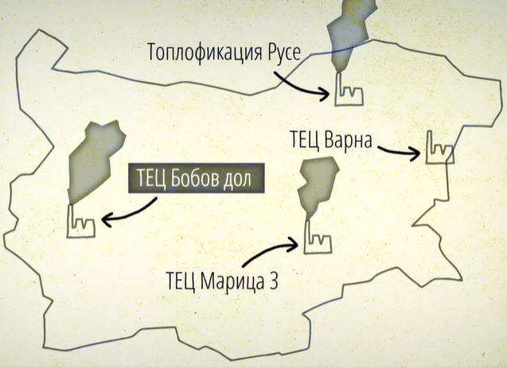

ALL DSO + all other

[Токът става 4 пъти по-скъп, когато слънцето залезе (capital.bg)](https://www.capital.bg/biznes/energetika/2023/08/28/4522544_tokut_stava_4_puti_po-skup_kogato_slunceto_zaleze/?fbclid=IwAR0brhAN2HKOwFeW2AWGeHFAMHgEKmQr66-k68zj3erV6KLJet6roZ7o4Jo)

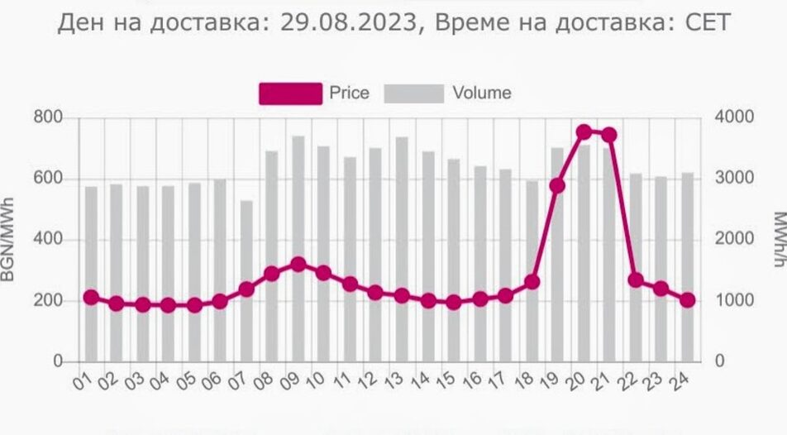

Можем да вземем цената от борсата и да симулираме DSO

The extra peak demand requirements are sometimes produced by **expensive** [peaking plants](https://en.wikipedia.org/wiki/Peaking_plant) that are generators optimised to come on-line quickly but these too are becoming less common.

However, if the demand of electricity exceed the capacity of a local power grid, it will cause safety issue like burning out

A microgrid is a local grid that is usually part of the regional wide-area synchronous grid but which can disconnect and operate autonomously.[[34]](https://en.wikipedia.org/wiki/Electrical_grid#cite_note-microgrids-34) It might do this in times when the main grid is affected by outages. This is known as [islanding](https://en.wikipedia.org/wiki/Islanding), and it might run indefinitely on its own resources.

Compared to larger grids, microgrids typically use a lower voltage distribution network and distributed generators.[[35]](https://en.wikipedia.org/wiki/Electrical_grid#cite_note-academia-35) Microgrids may not only be more resilient, but may be cheaper to implement in isolated areas.